**ESD LAB Assignment 1**

Q1. a) On reset what is the ARM7TDMI processor's mode of operation?

Ans: Supervisor

Q1. b) How many states are taken for the execution of an Arithmetic instruction, Load and Store instruction respectively?

|  |  |  |
| --- | --- | --- |
| **Instruction** | **CLK State** | **PC State** |
| LDR | 3 | 8 |
| STR | 2 | 4 |
| CMP | 1 | 4 |
| BGE | 1 | NA |
| ADD | 1 | 4 |
| SUB | 1 | 4 |
| MOVLT | 1 | 4 |
| STRLT | 2 (if true) else 1 | 4 |
| ADDLT | 1 | 4 |
| SUBGE | 1 | 4 |

Q1. c) Are the number of states taken for completion same for BGE instruction if the branch – (1) is taken (2) not taken?

Ans: No, if branched the code take 3 extra instruction cycles to execute.

Q1. d) Measure the performance of code-1 and code-2 for the following conditions.

Assumption: The states are captured as soon as the program reaches STOP label i.e. *STOP B STOP*

|  |  |  |
| --- | --- | --- |
| **Condition** | **Code-1 State** | **Code-2 State** |
| a>b | 29 | 29 |
| a<b | 33 | 30 |
| a=b | 29 | 29 |

**CODE-1 Execution:**

**A > B**

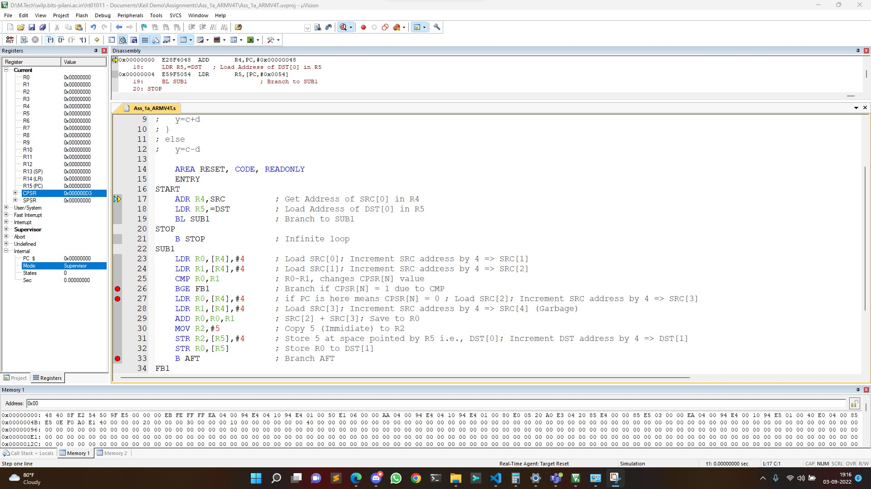

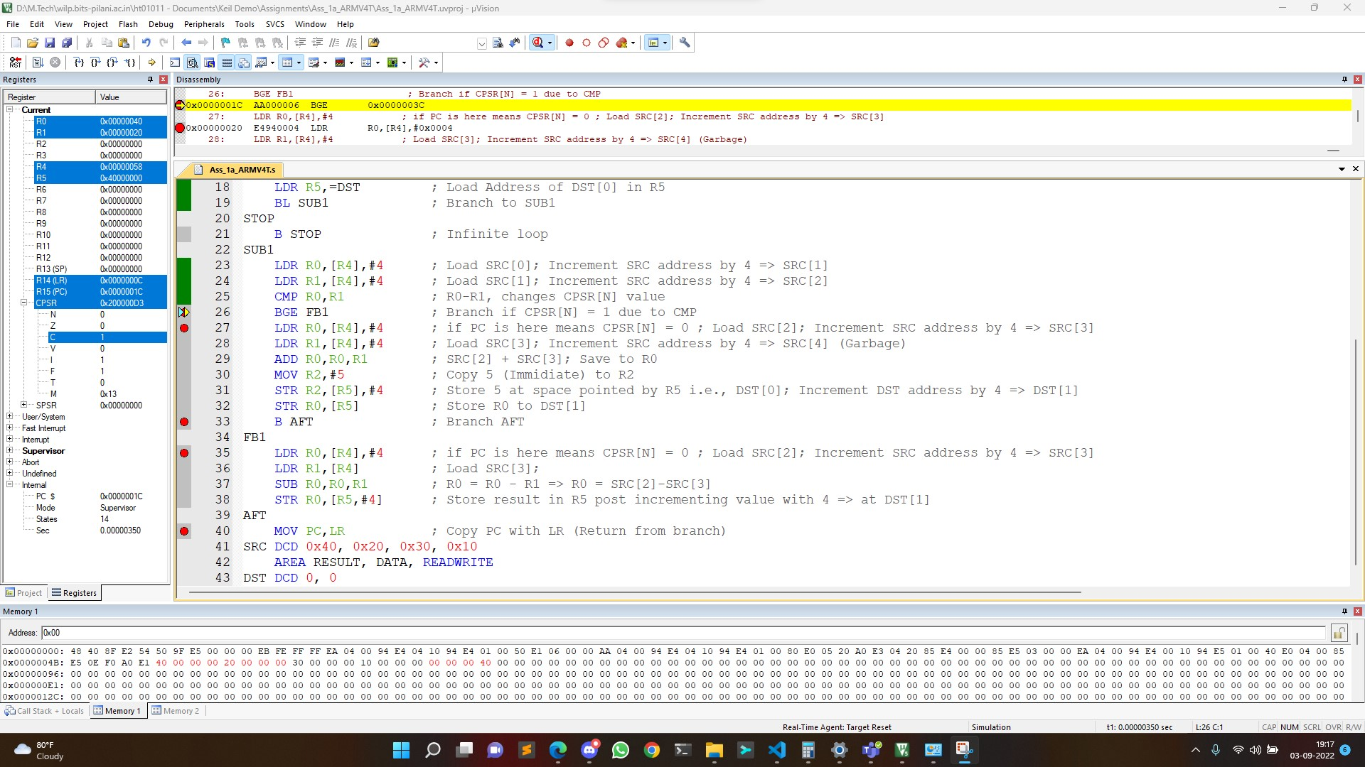

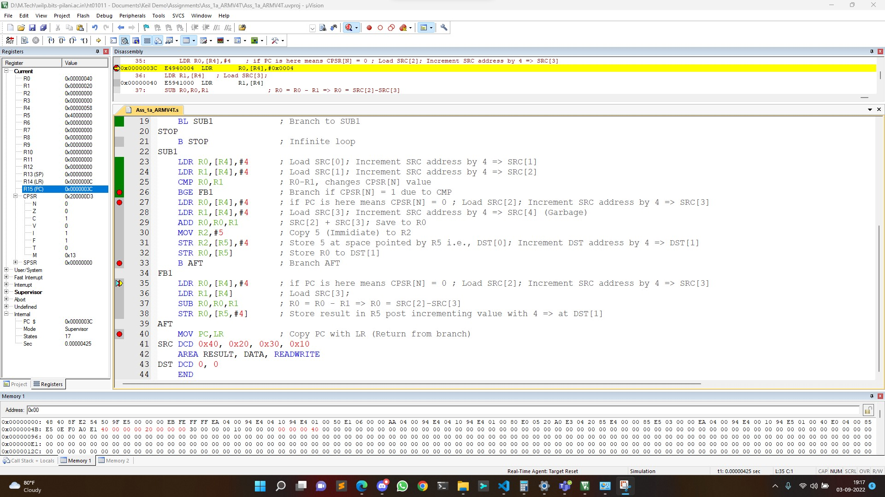

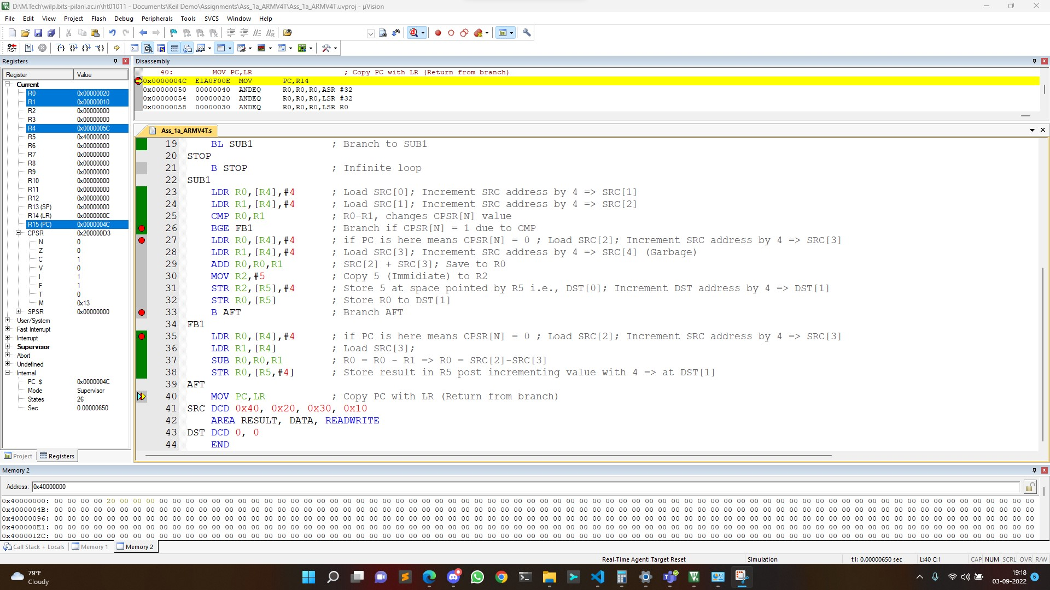

**A < B**

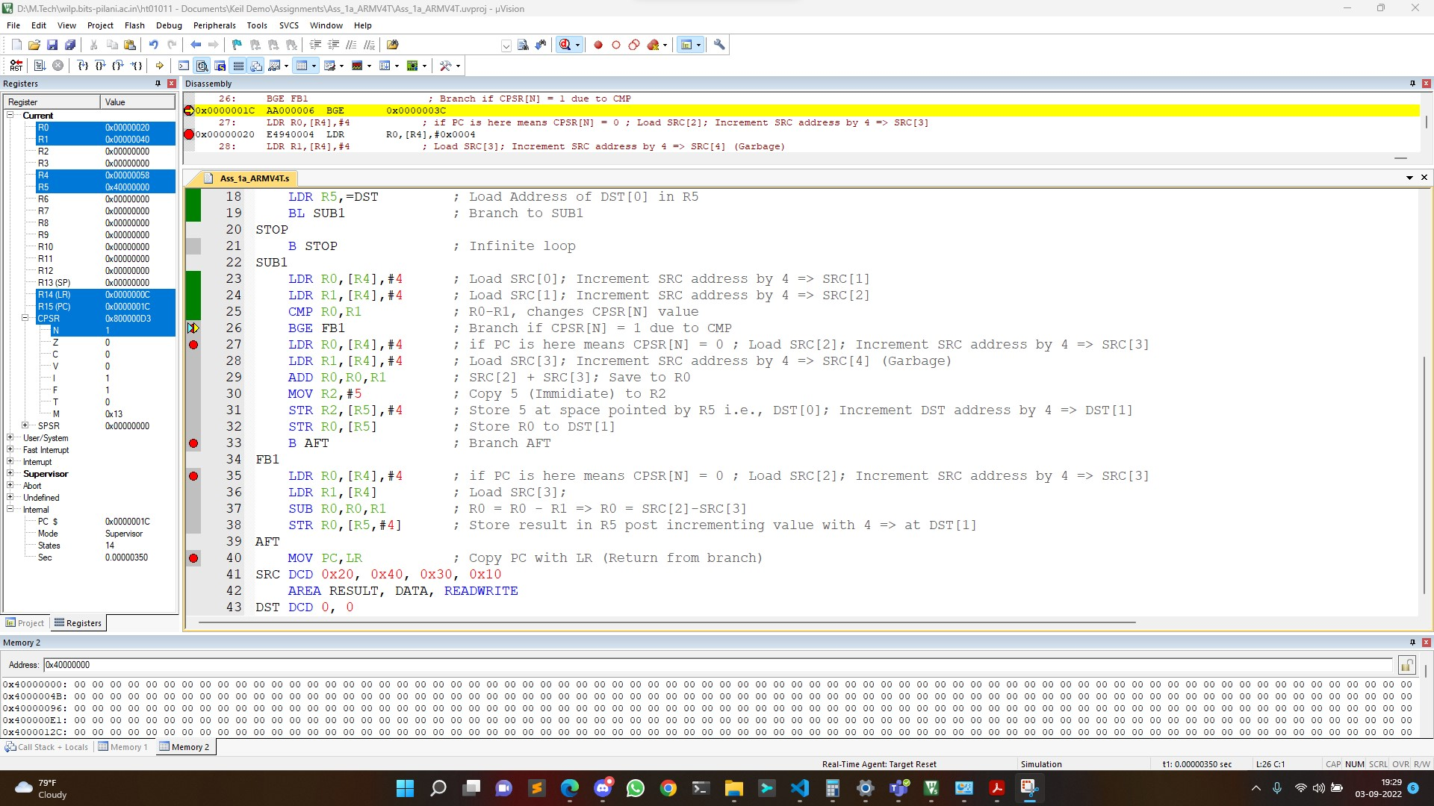

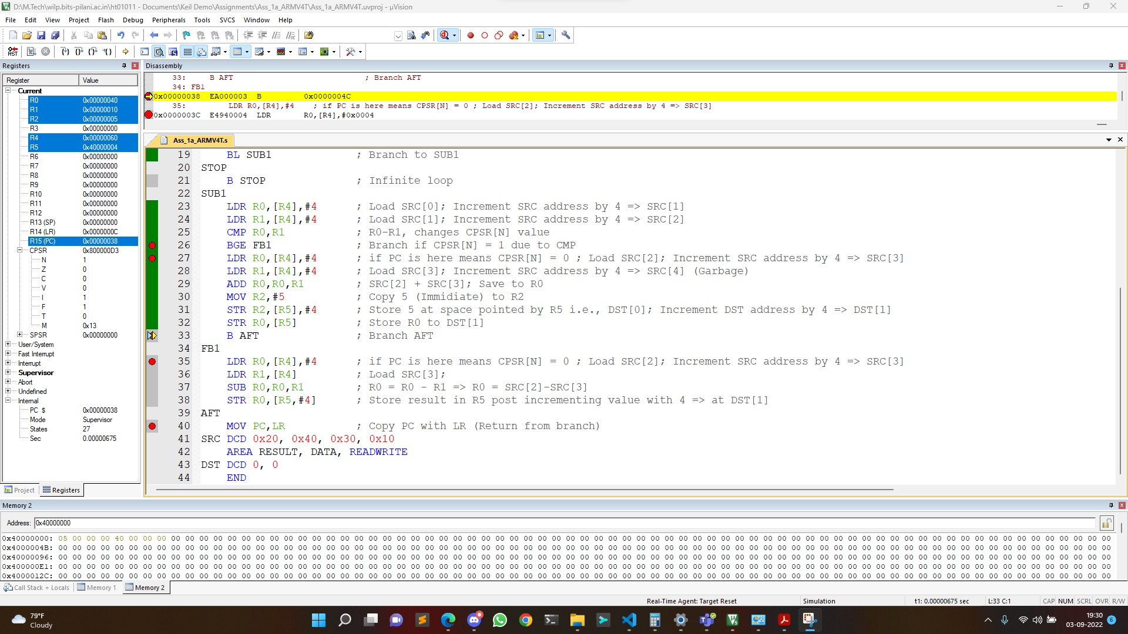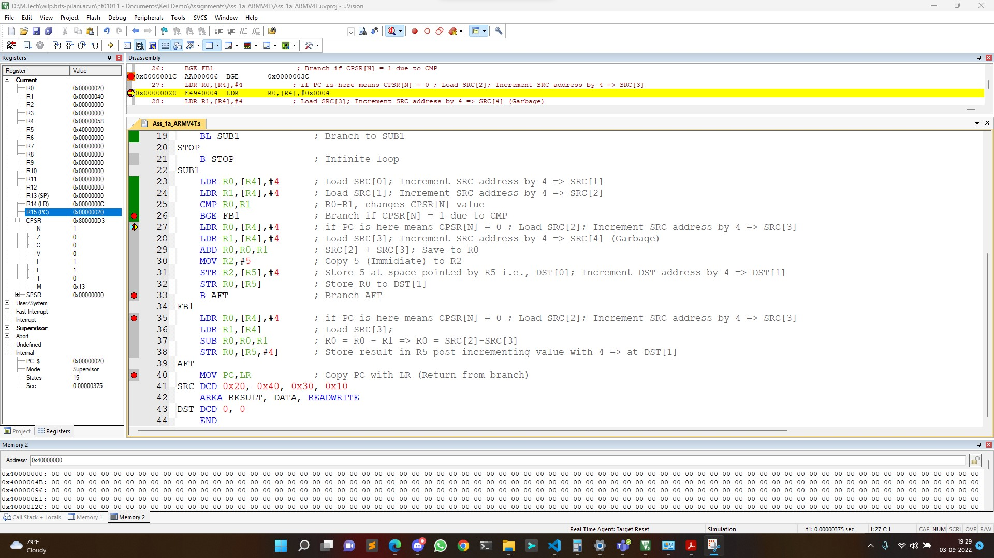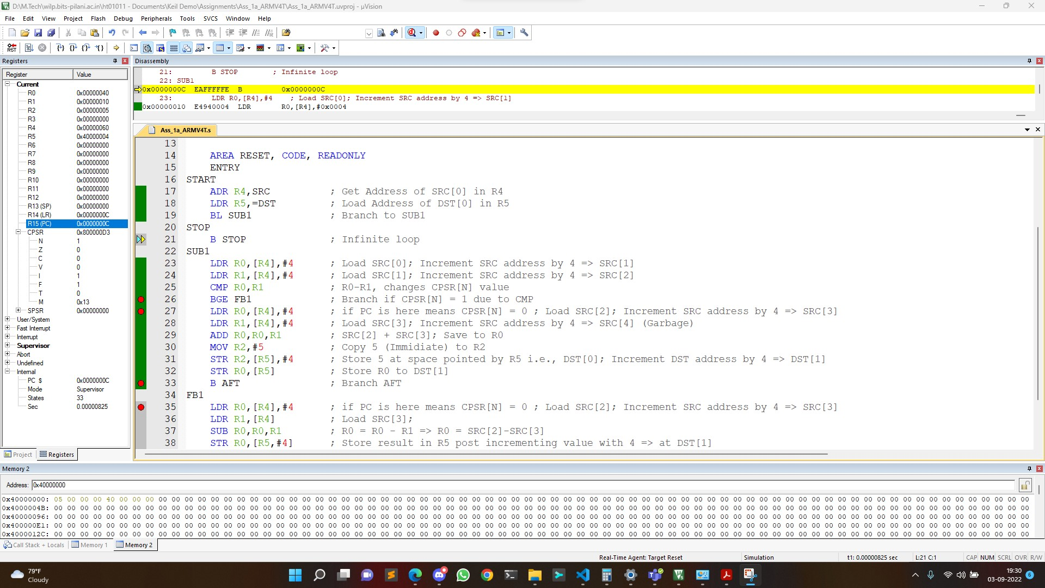

**A=B**

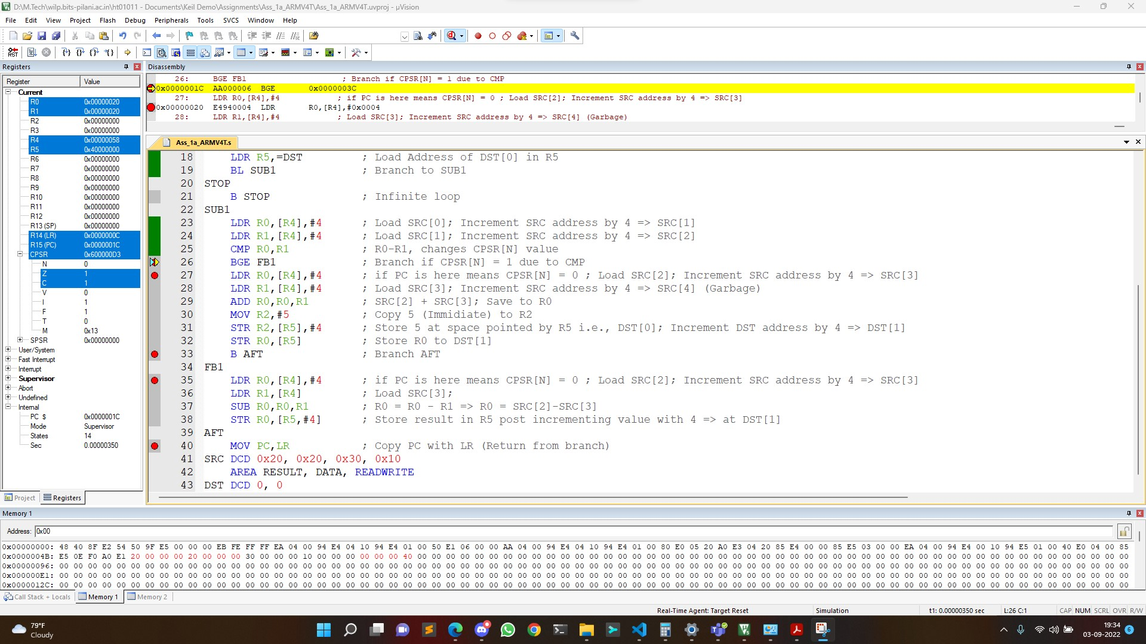

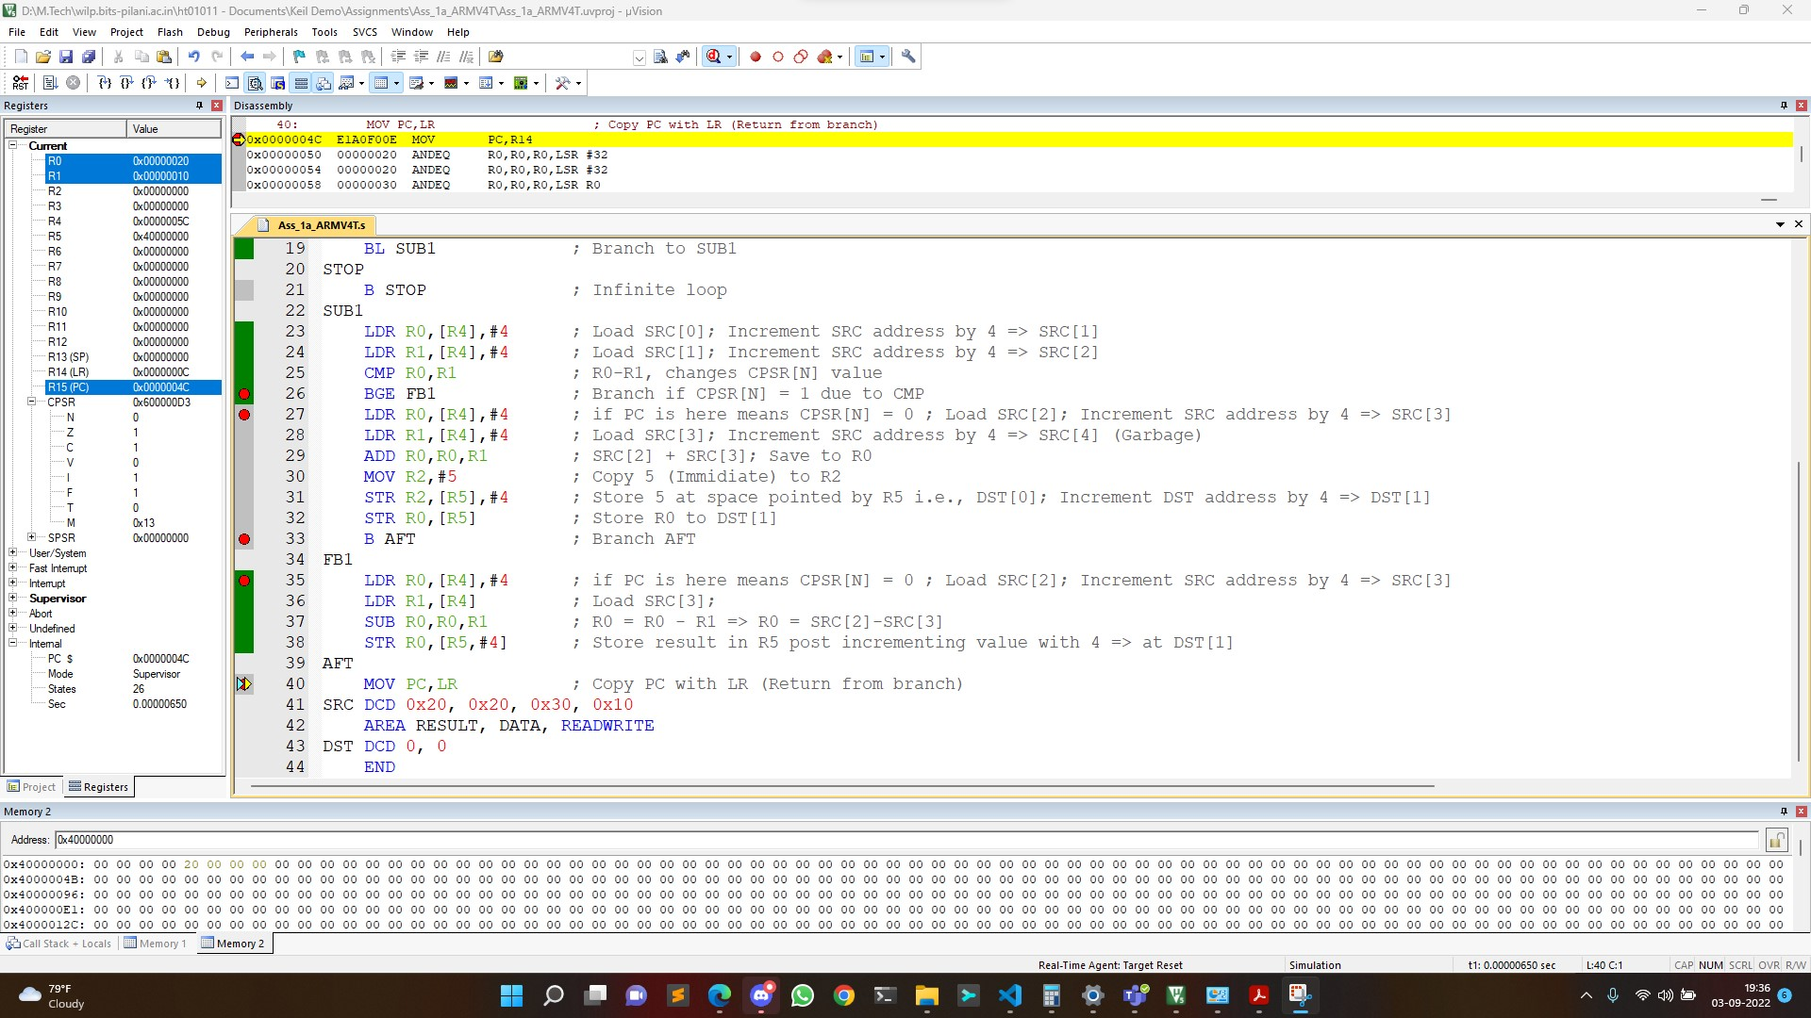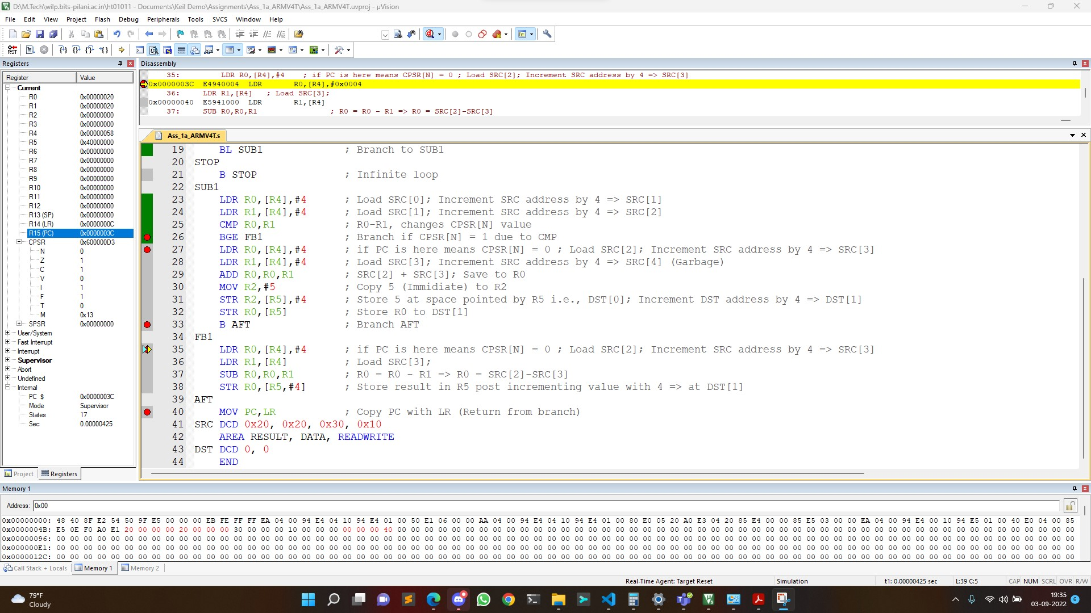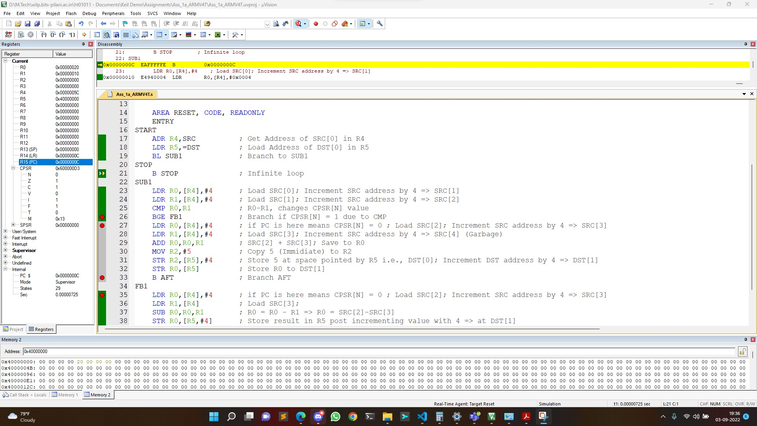

**CODE-2 Execution**

**A>B**

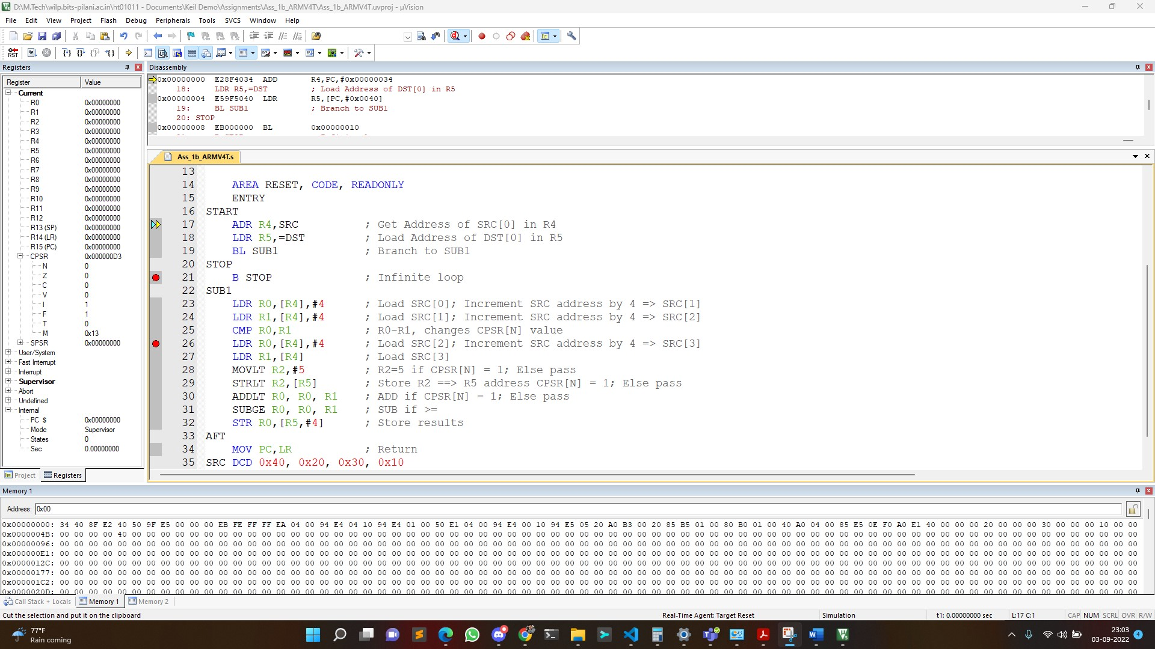

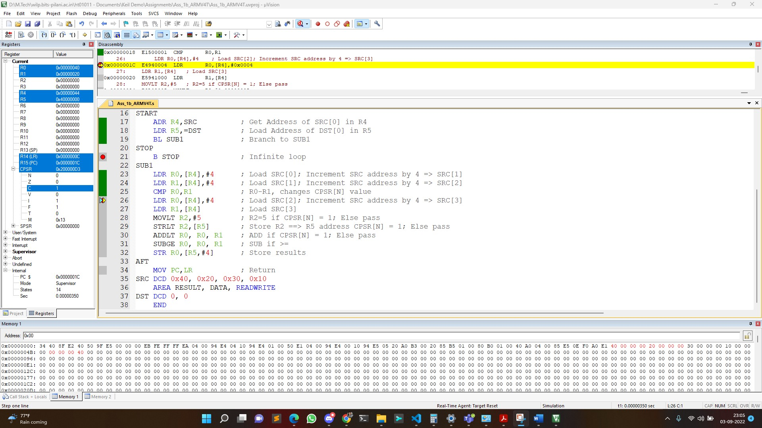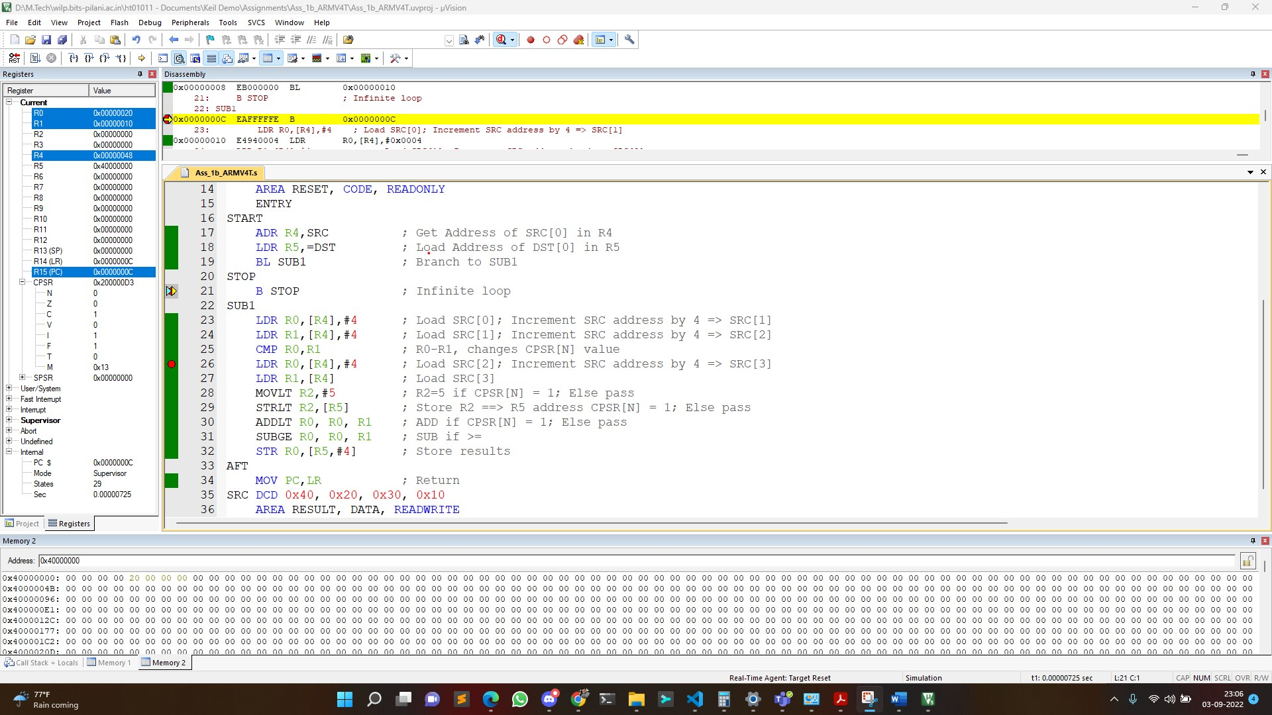

**A<B**

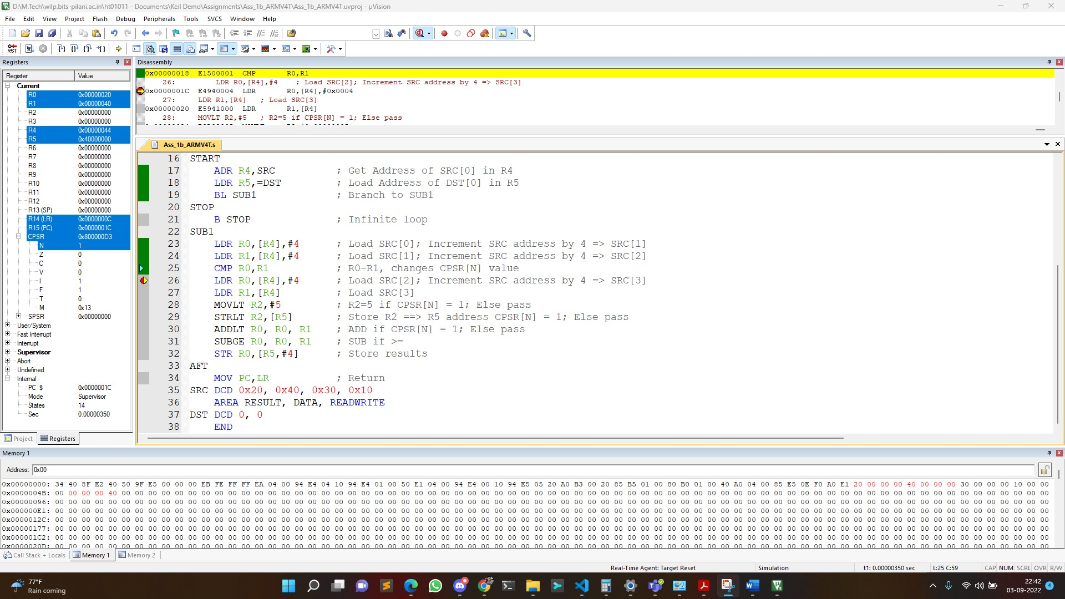



**A=B**

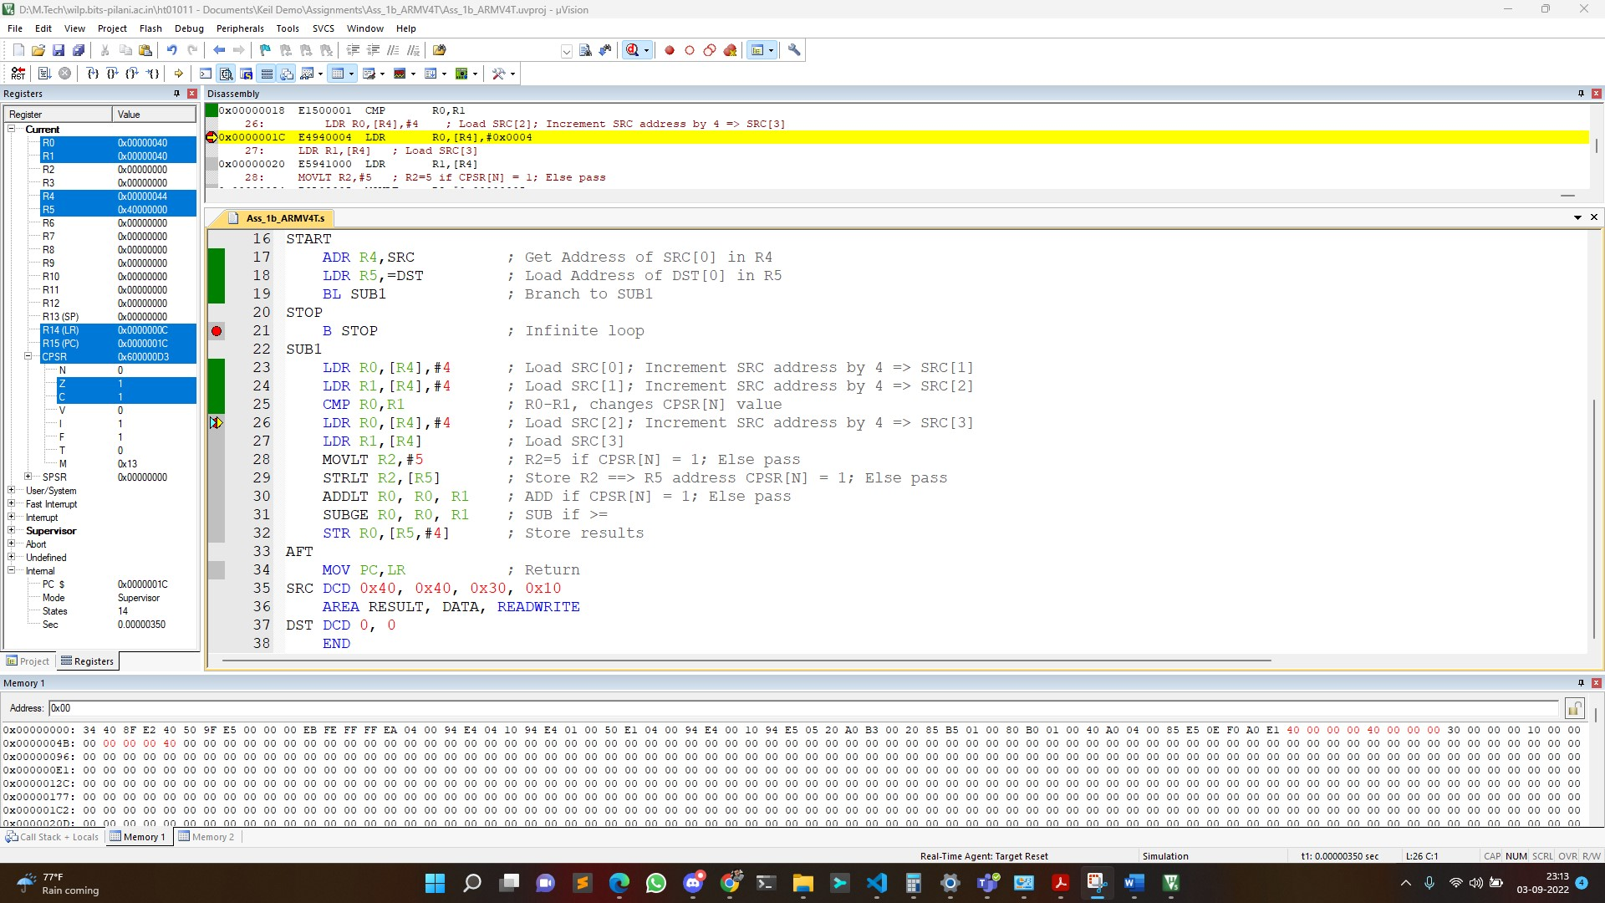

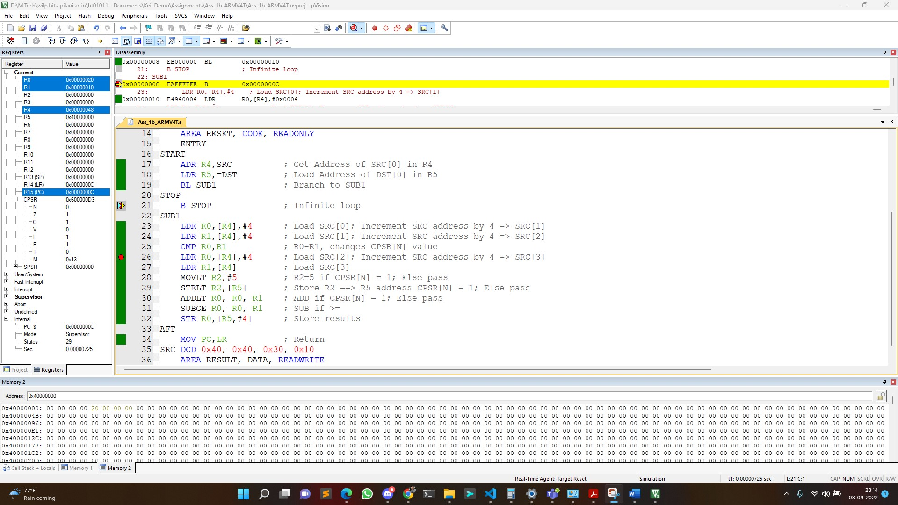

Q.2. Write an assembly language program (ALP) in Keil uV5 for STM-32 to find the largest integer from a collection of 10 signed integers stored in consecutive memory locations in ROM and store the result in RAM. Also take a suitable snapshot of the KEIL IDE in the debug mode to demonstrate the desired output (Register window, Memory window for RAM/ROM). Ensure that the screenshot captures system time & day. Comment your code.

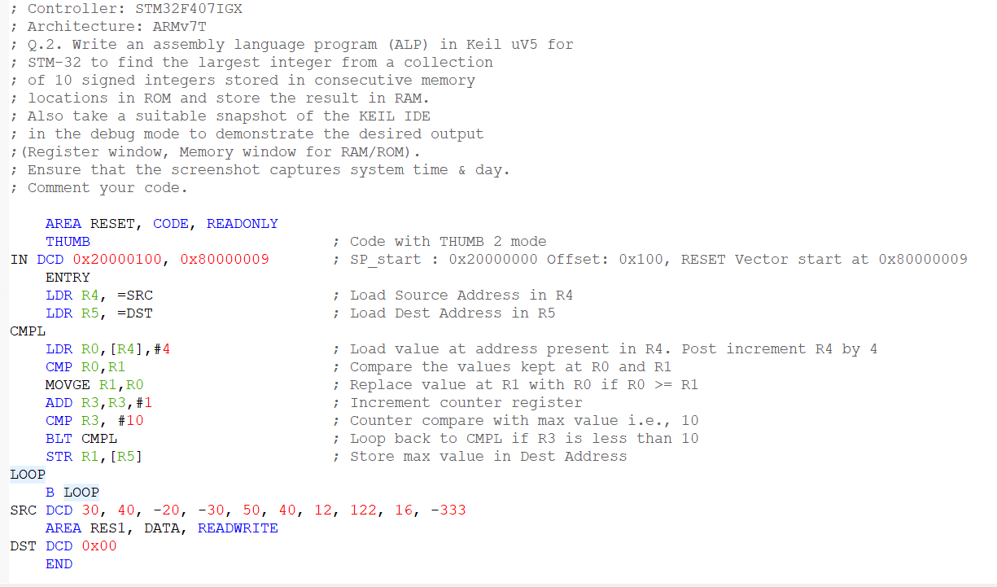

Figure 1: ASM Code

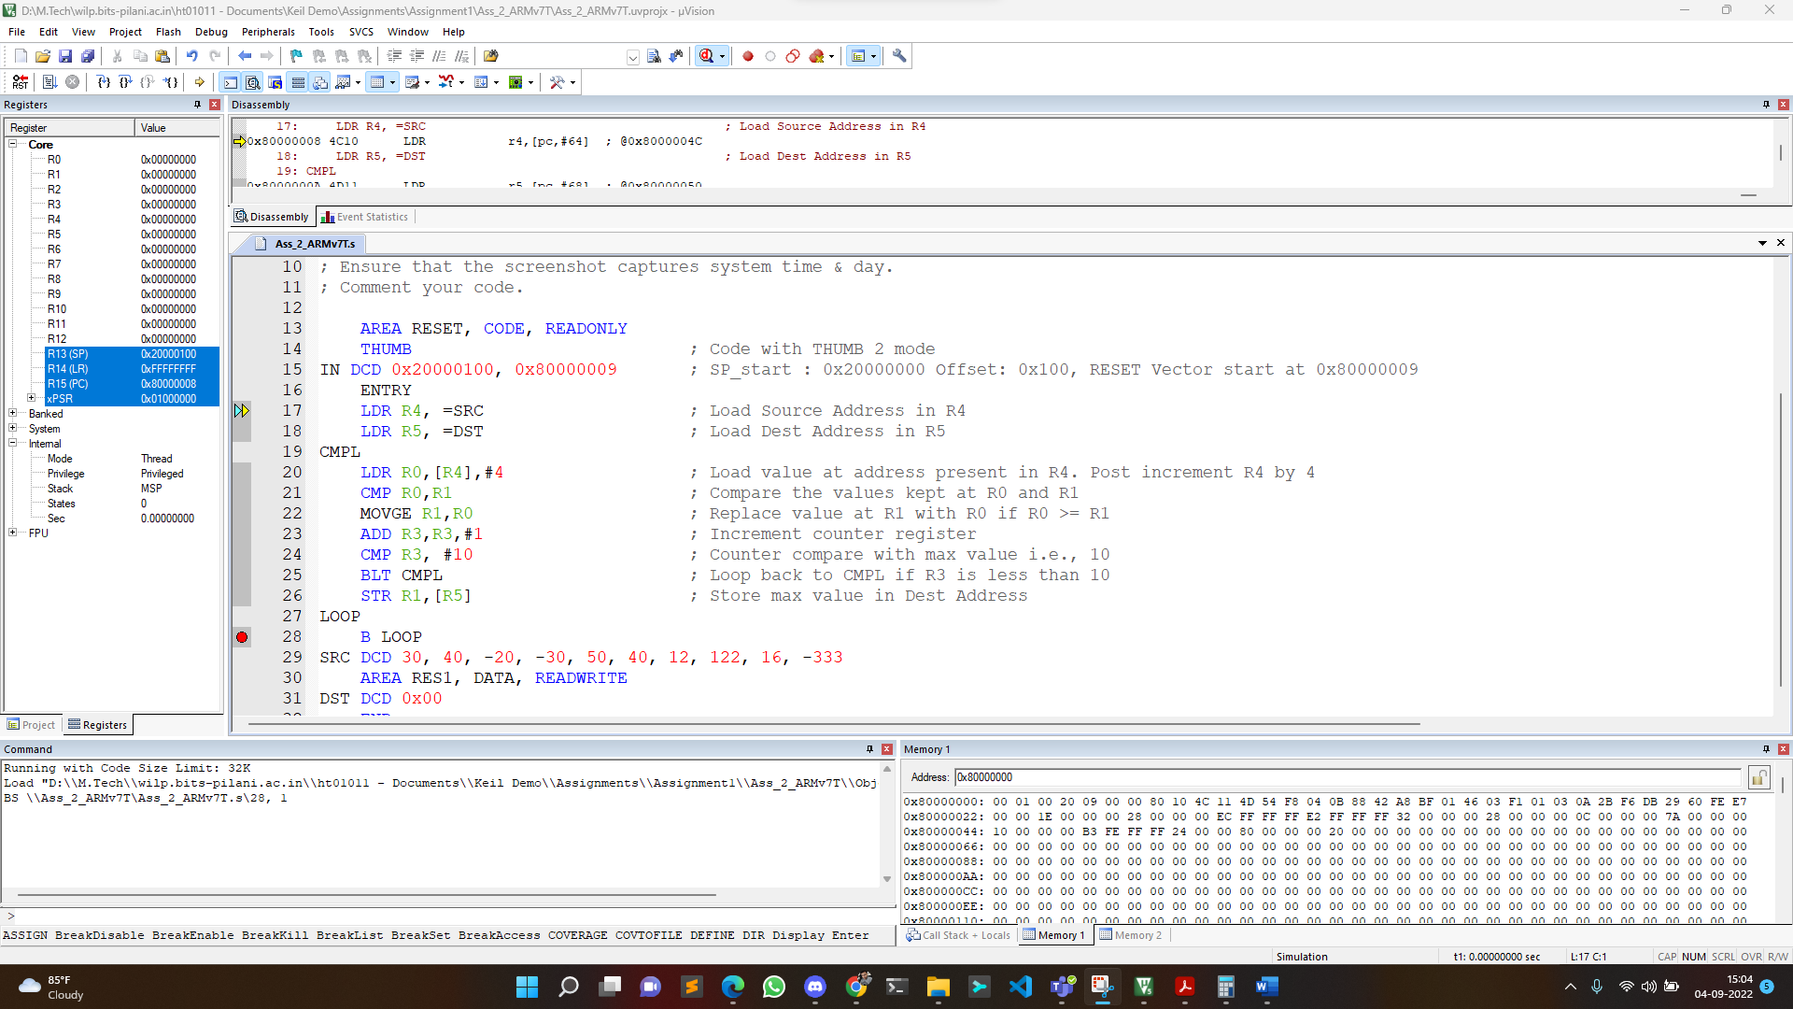

Figure 2: Code Start

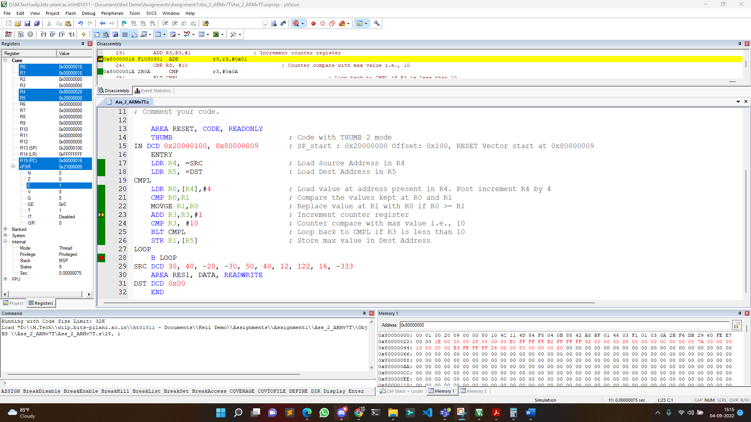

Figure 3: Iteration 1

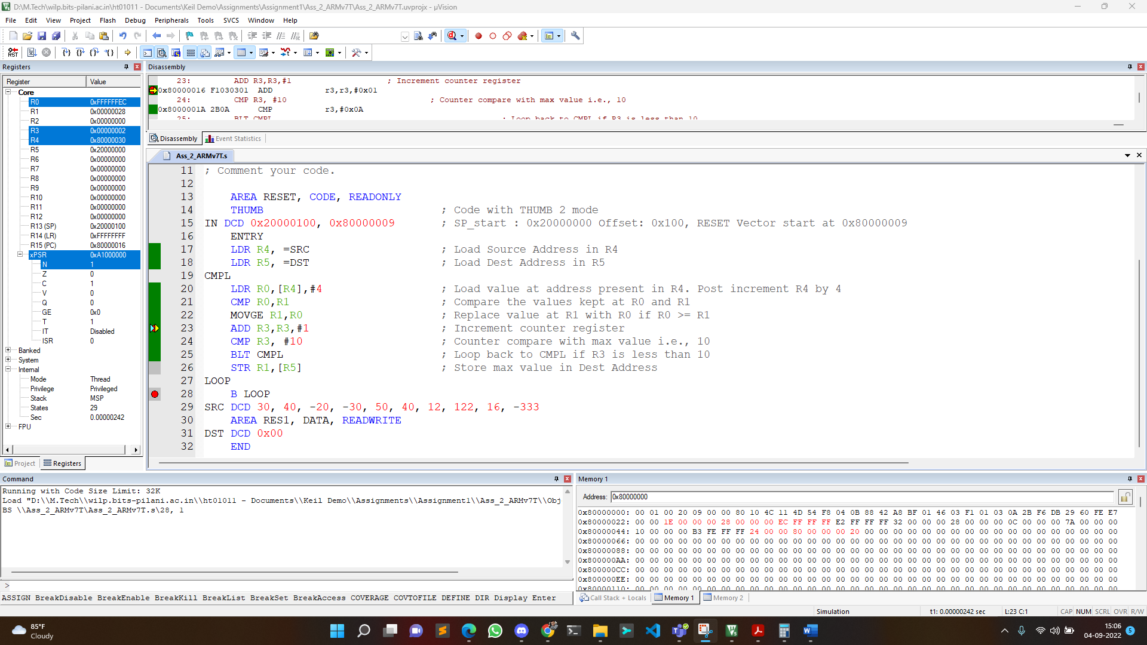

Figure 4: Iteration 3

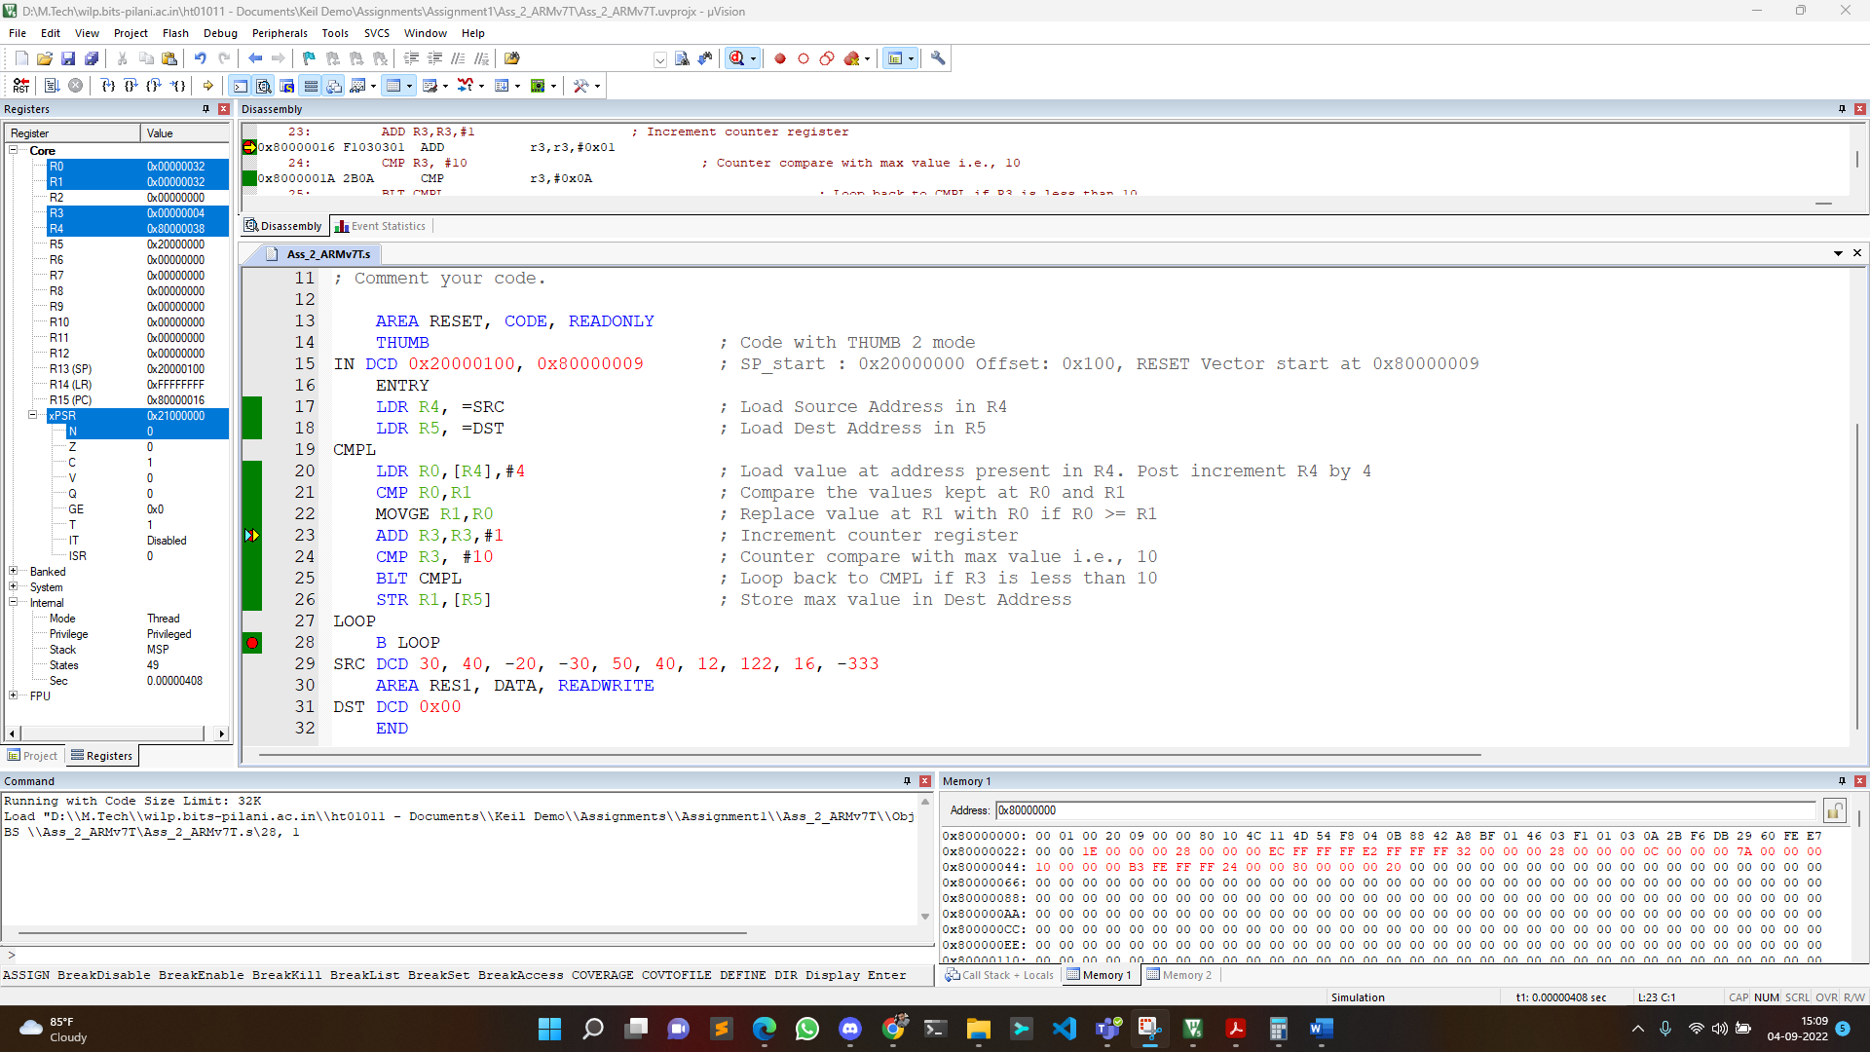

Figure 5: Iteration 5

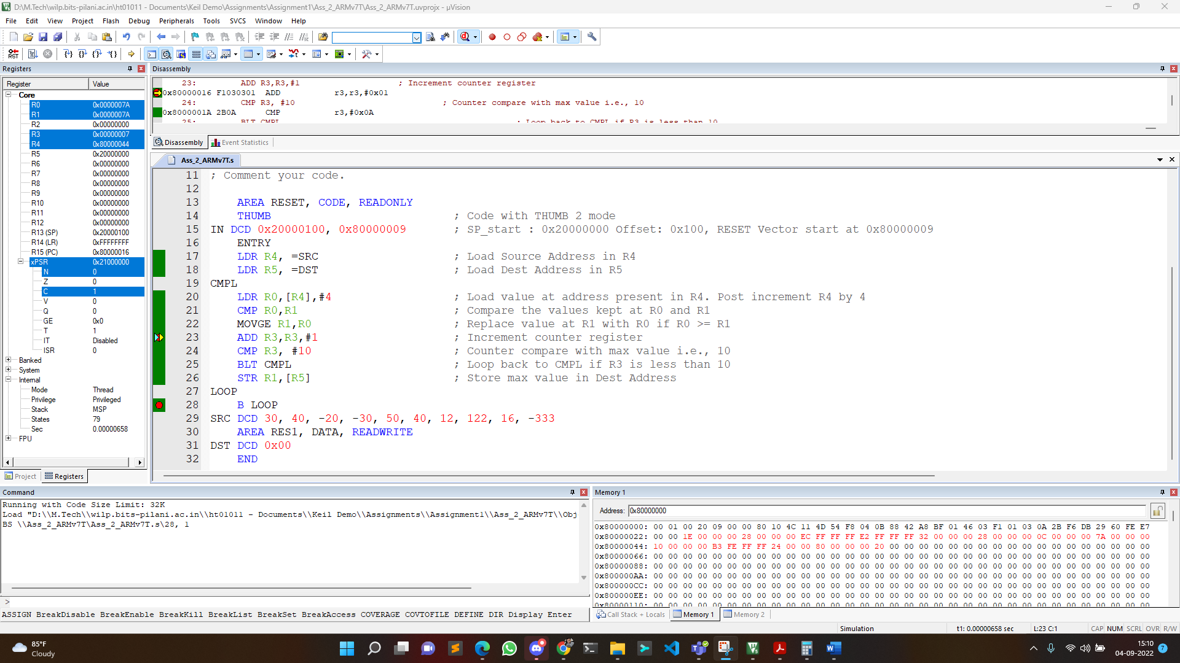

Figure 6: Iteration 8

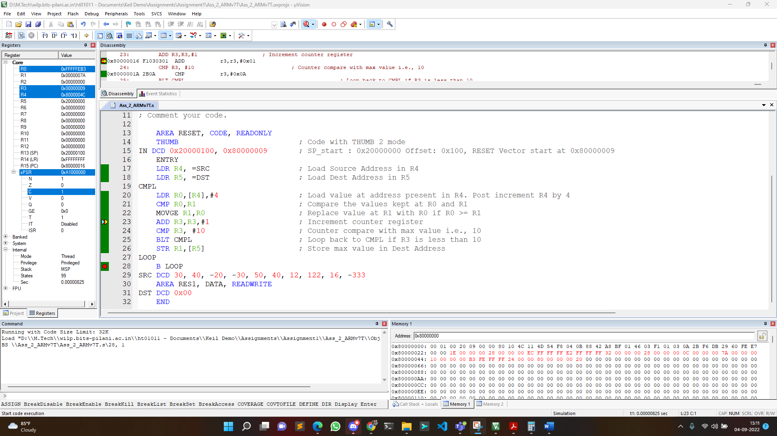

Figure 7: Iteration 10

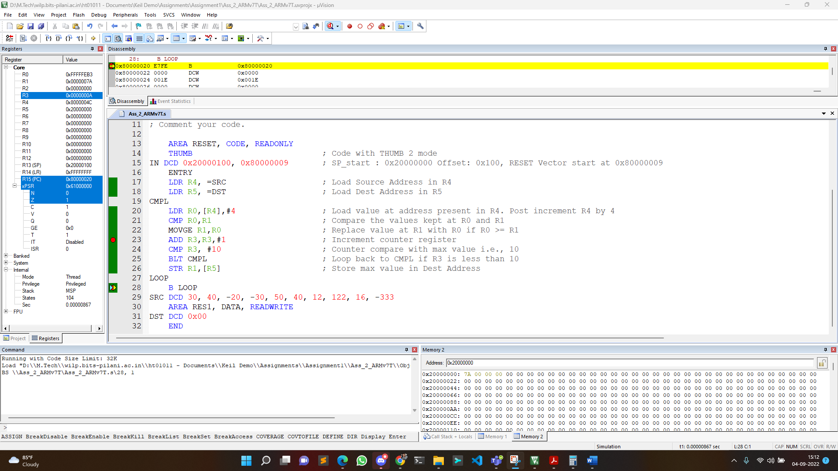

Figure 8: Code Completion

*The code took 104 states to complete its execution.*